Working with RDS

STEPS

1.Launch an UBUNTU t2 micro instance in AWS console

2. Click on RDS >DB instance> Launch DB

3.Select My sql>Dev Test

4. Enter the details in each entries as below and click next step

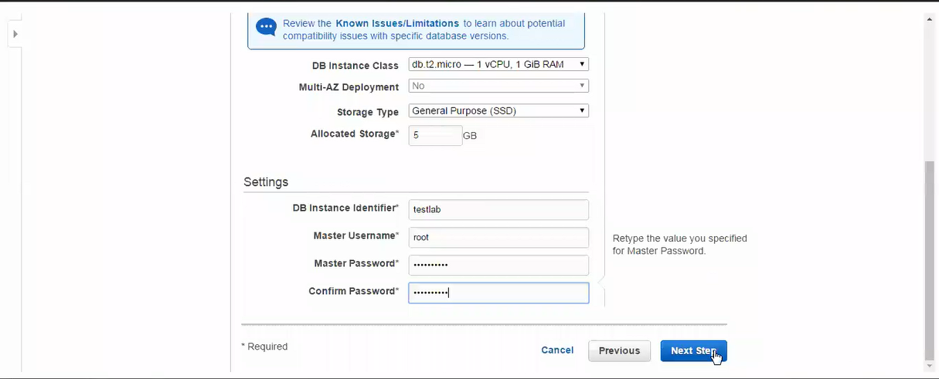

5.Do not change the default entries in free tier , Enter the details in each entries as below and click launch DB instance

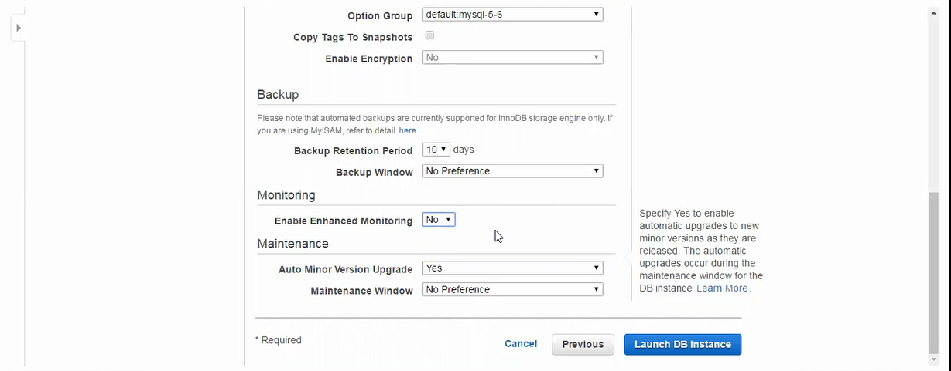

6.Connect to the UBUNTU instance by typing ssh Ubuntu@public dns of the Ubuntu instance and provide the key pair to login

7.Type sudo apt-get update to update the linux

8.Select the security group of the DB instance as below

9.Copy paste the endpoint url of the DB instance and connect to the DB instance as below

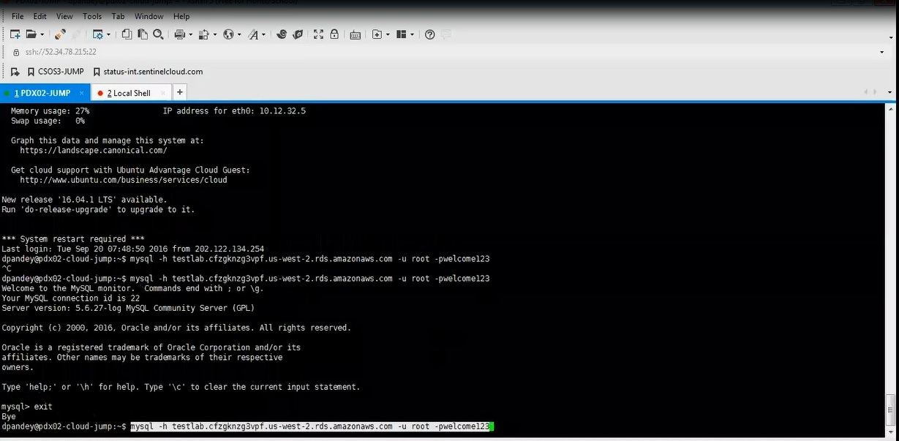

10.Type show databases to list the databases

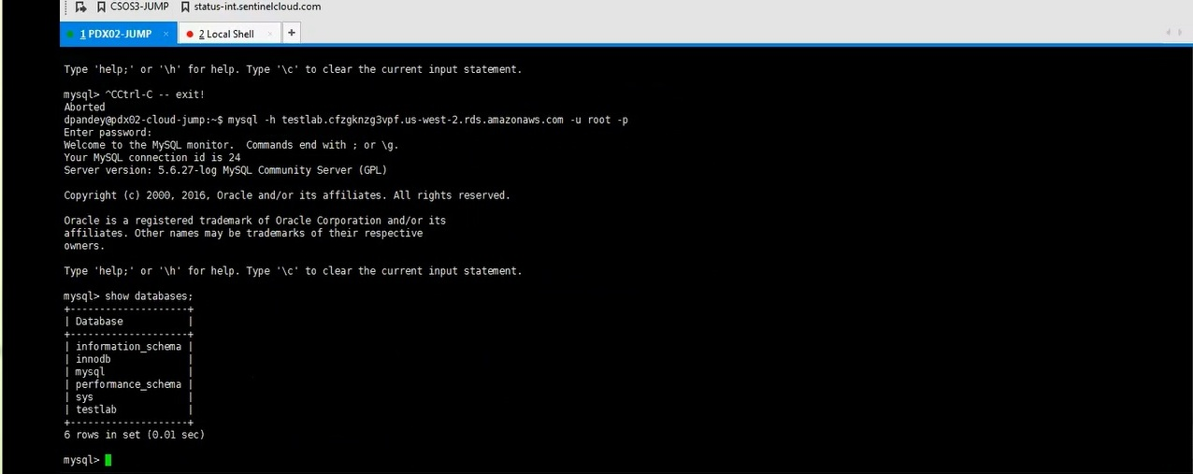

11.Create a backup directory and install world.sql zip file by the commands below

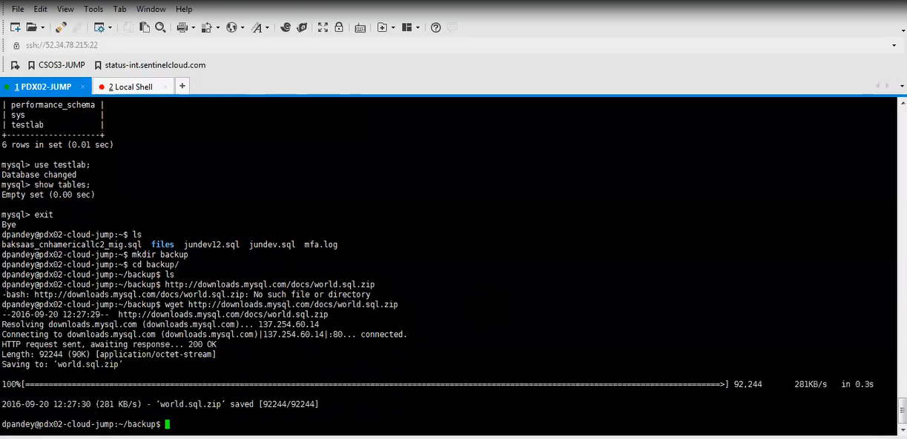

12.Type unzip world.sql.zip

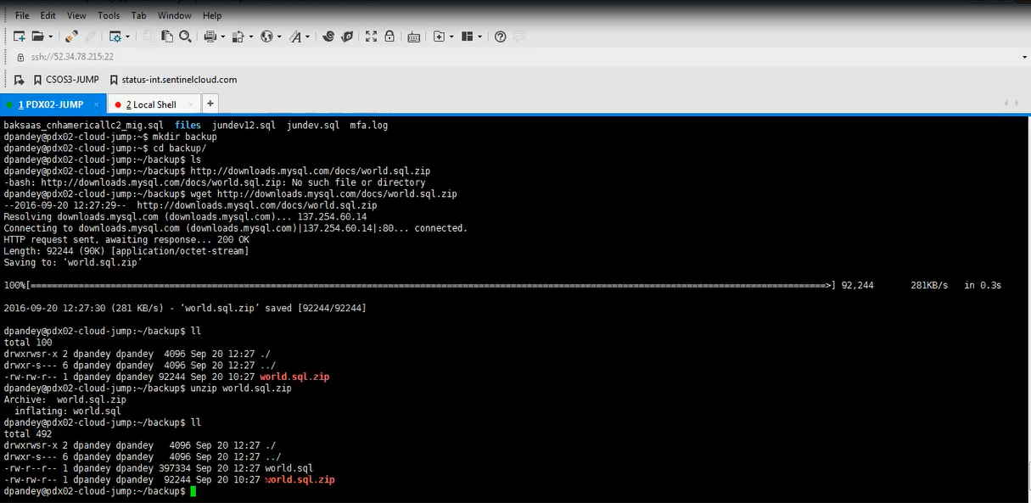

13.Enter in to the rds again and transfer the data from local to rds by typing source world.sql; as below

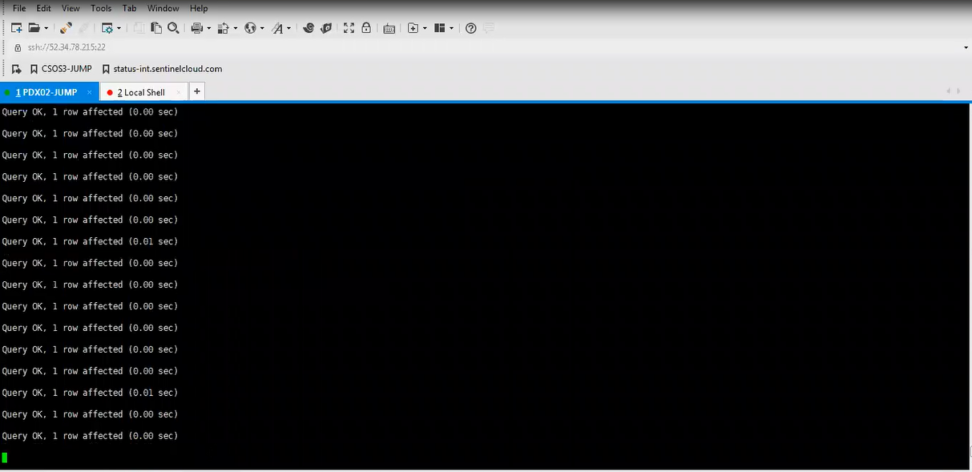

14.Type show databases;

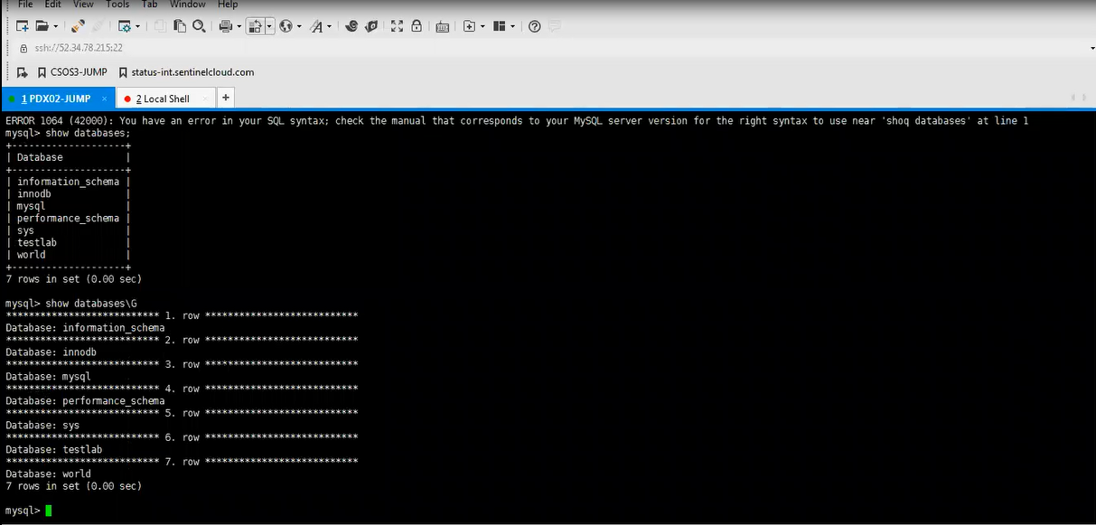

15.Type the command use world; and show tables; to list the contents in world.sql file

